Om bahadur Shrestha

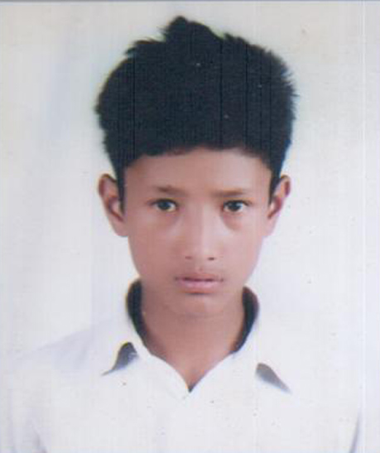
Om bahadur shrestha is a student of grade 10 studying at Shree Durga Higher Secondary School from Maghapauwa. He is an attentive student in class with good marks obtaining in his batch. Being good in education sector, he is also intrested in football. He just loves football. His both Academic and extra curricular activities are praiseable.
In the recent earthquake, he lost his father. After death of his father, the economic condition of his family became worst. Although he lost his father and is economically weak, He wants to gain more education and become an engineer so that he can bulit earthquake resistance homes and nobody becomes victim of earthquake and also a stadium for football, he mentioned.

